INTRODUCTION

1.1 OVERVIEW

This Global Air Transportation Network dataset is a comprehensive collectionn information on airlines,airports and their routes.It contains information such as names,cities,countries,codes,longitudes,latitudes and altitudes of airports across the world with detailed time zone and daylight saving time data.

1.2 PURPOSE

This Global Air Transportation Network dataset is a comphensive collection information on airlines,airports and their routes. Additionally, this includes information about aielines incliding their ID's,name aliases TATA and ICAO codes, callsigns country of origin and active status.The travel and transportation industries never lacked data,asit's collected across every interactioon point.

PROBLEM DEFINITION AND DESIGN THINKING

2.1EMPATHY MAP

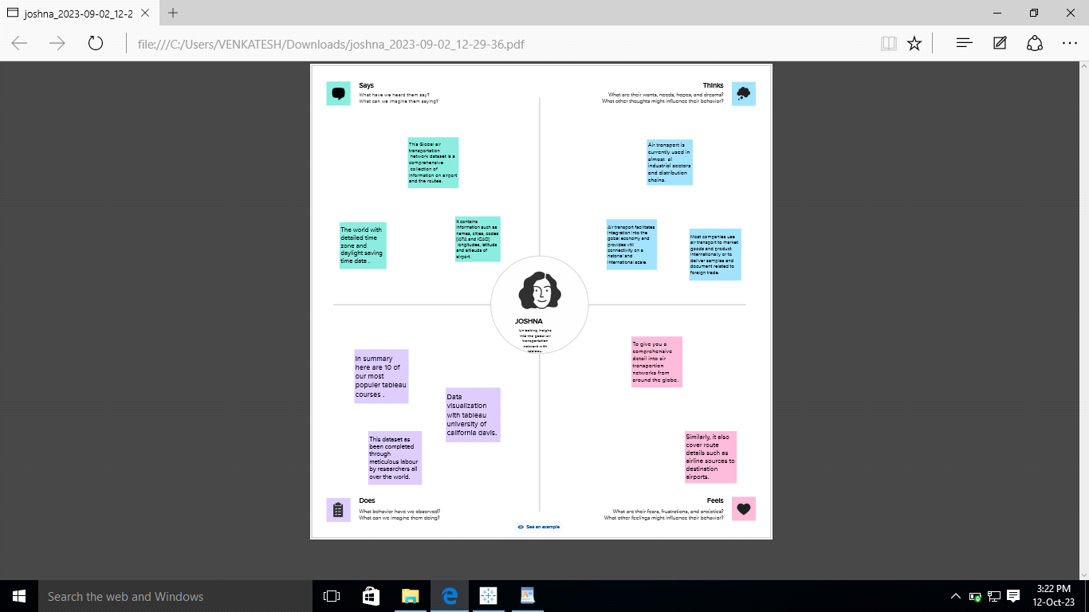

2.2 IDEATION AND BRAINSTORMING MAP

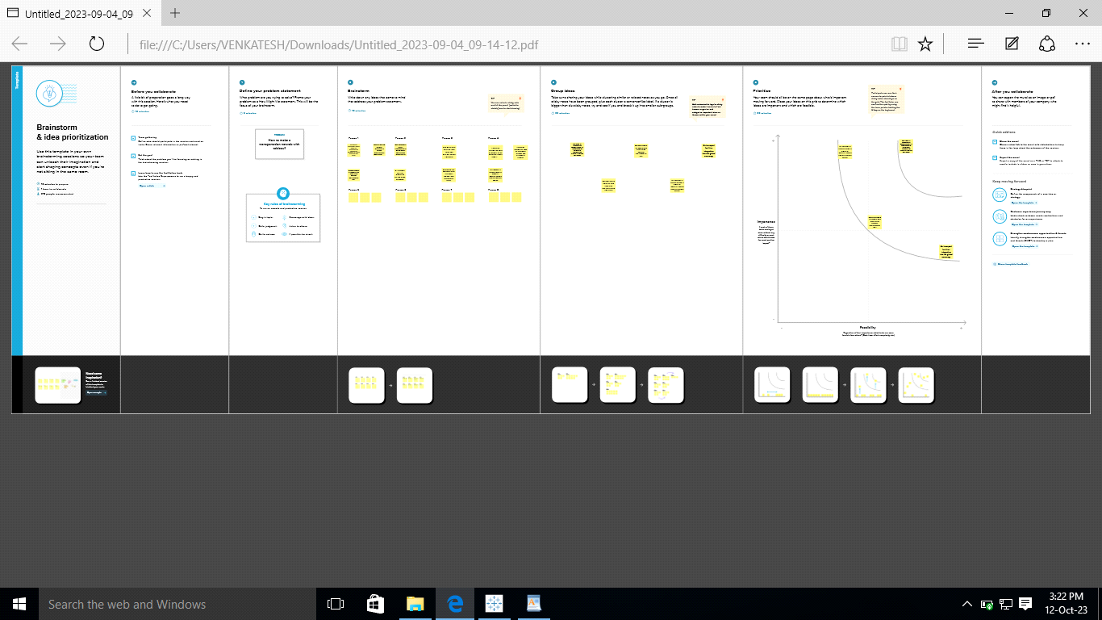

RESULTS

3.1 DASHBOARD AND STORY

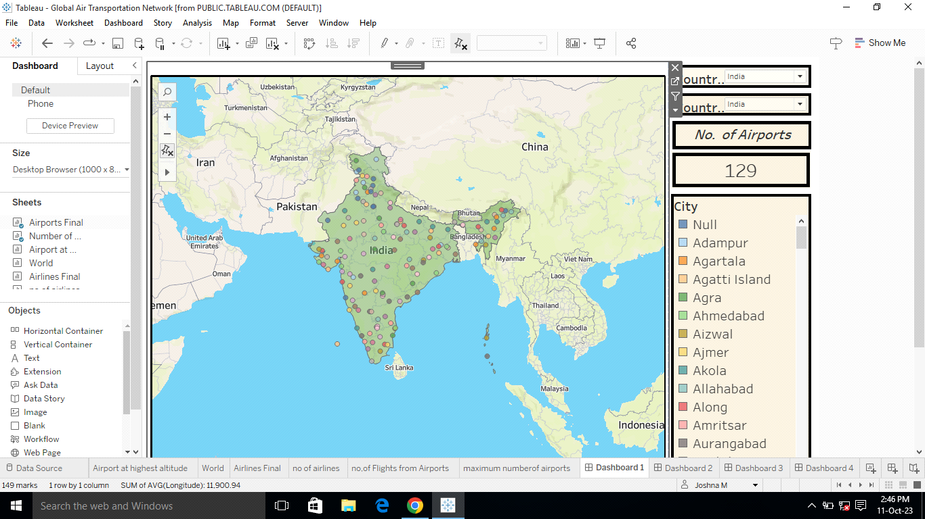

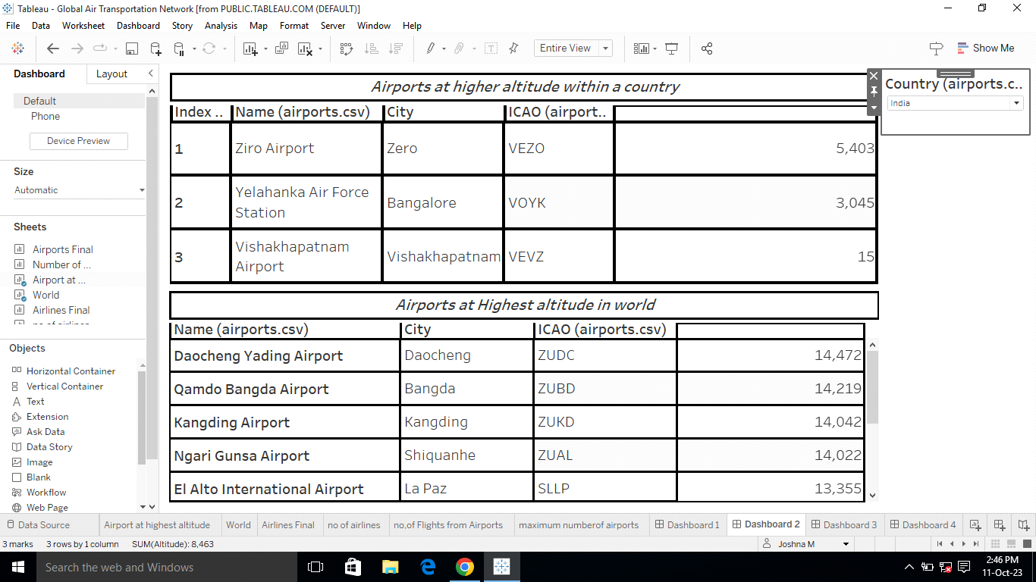

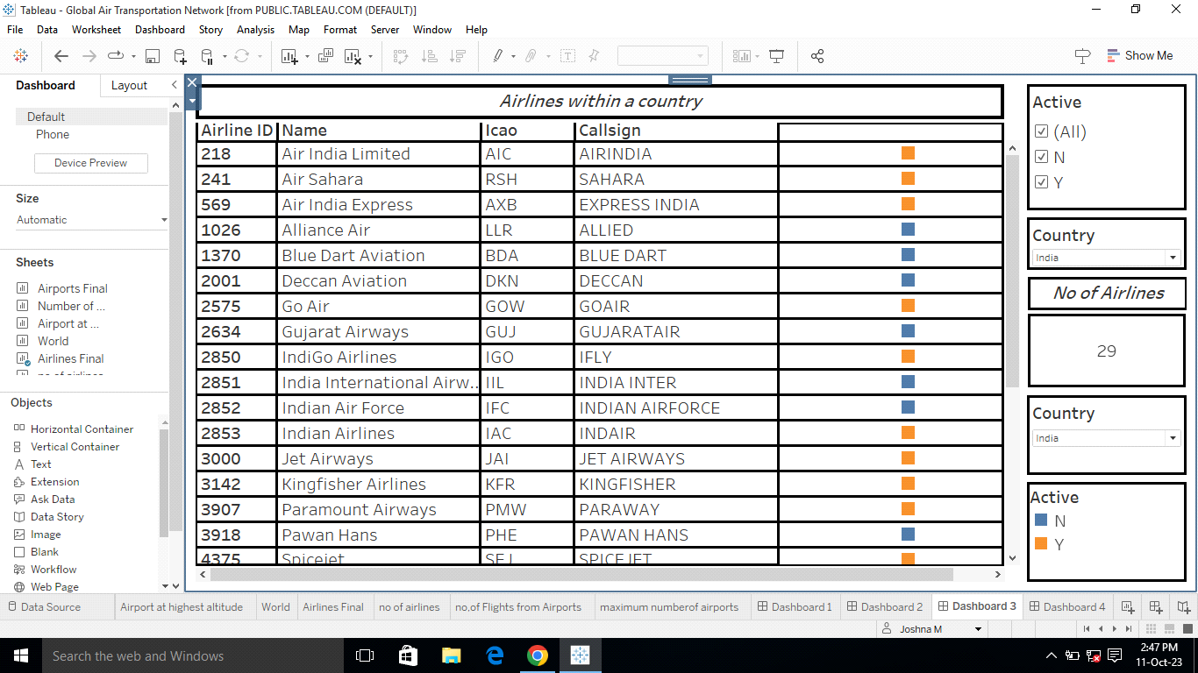

ADVANTAGES AND DISADVANTAGES

1. Advantages of Air Transport

Global Reach

Reliable Timelines

Reduced Inventory Holding Costs

Enhanced Security

2. Disadvantages of Air Transport

Higher Cost

Limited Capacity

Restriction on Hazardous Goods

Speed and Efficiency: One of the key advantages of air transport is its unparalleled speed. Airports can cover long distances in a matter of hours, enabling businesses to deliver goods quickly, esoecilly for time senitive orders.This swift transportation option is particularly beneficial for industries such as e-commerce, phaemaceuticals, and perishable goods.

APPLICATIONS

Information technology system supports a lot of functions including reservation management, ticketing, and inventory management . The Airline Company has a number of branches and distributors over the globe. Air transport networks are complex networks that span across multiple distance scales and multiplex.

CONCLUSION

As the industry continues to evolve, IATA will remain an important player in shaping the future of air transport. In conclusion, the international Air Transport Association has been instrumental in developing and improving the air transport industry.

FUTURE SCOPE

TheWorld Economic Forum proposes that the deployment of these private sector and government innovations to address mobility challenges can comtribut to an improved mobility landscape­­ - if they are deployed in a coordinated and collaborative way that aims to optimize the entire transport system. Unfortunately to date , these efforts in many instances may be exacerbating transport issues, most notably by adding congestion and complexity while also creating inefficiencies between public and private modes of transport.

APPENDIX

Air transportation plays an essential role in the global economy . Therefore, there is a great deal of work to understand better the complex network formed by the links between the origins and destinations of flights. Some investigations show that the world air transportation network exhibits a community and a core-periphery structure. Although pricious, these represntation do not distinguish the inter-regional(global) web of connections from the regional(local) one.